**Kindergarten Schedule**

8:00-8:10 Family Literacy

8:10-9:40 Mathematics

Language Arts

Blended Learning (i-pads)

9:40-9:45 Bathroom Break

9:45-10:00am Recess

10:00am-11:30am Whole Group Reading

English Language Development

Science/Social Studies

Computers/Library/Physical Education

11:39-12:26 Lunch

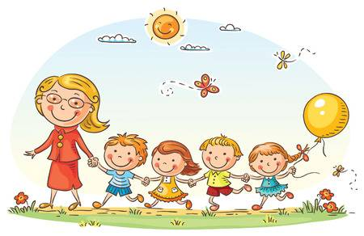12:30-2:00 pm Mathematics

Language Arts

Blended Learning (i-pads)

2:00-2:10 Clean up/Backpacks/ Notices

2:13 Dismissal